[Event logo]

Risk Management:
Traffic Management

[Event name]

[Event date]

Event Start

Overview
The event will be held on [date], starting at [time] and finishing at [time].
The Start, Finish, Rally Headquarters and Service Park will be located at [location].
[Description of event format]

Risk Management – Traffic Management Plan

Traffic Control – Competitive Stages
All Competitive Stages (also known as Special Stages) for this event are conducted in [State Forests/Shire roads/both?].
The highest level of risk associated with this type of event is seen to arise from the possibility of a collision involving a competitor on a Competitive Stage. Safety of the general public, spectators, competitors and officials is of paramount concern in an event of this nature and the closure of sections of road to all but competitive traffic for the duration of each Special Stage is a key component of the safety planning.
This road closing process involves the placement of a series of road closures followed by the passage of a number of official vehicles prior to the start of competition to check specified closures are in place and that no unauthorised vehicles are within each Stage.

Road Closures
Roads are closed to general access between one and two hours before the scheduled start of the first competitive vehicle. Once the road closing procedure has commenced on a Special Stage, permission must be gained from Rally Headquarters before any ‘non official’ vehicle is allowed to travel on a ‘closed’ road.
There are five types of road closures required for the event and the appropriate risk assessments, diagrams and lists of locations are attached as shown in the following table.

No. | Type | Risk Assessment | Diagram | Locations
1 | Special Stage Start | Appendix A | Appendix C | Appendix H
2 | Special Stage Finish | Appendix A | Appendix F | Appendix H
3 | Intermediate – Manned | Appendix B | Appendix D | Appendix H
4 | Intermediate – Unmanned | Appendix B | Appendix E | Appendix H *
5 | Spectator Point (same as “Intermediate Manned”) | Appendix B | Appendix G | Appendix H
* Each point not already covered where a road or track meets the competitive course will be bunted and signed.

Course Cars
Course cars traverse the course in order to ensure the safety of the course and readiness of the Special Stages. They are under the command of the Clerk of Course and travel exactly the same course as the competing cars. Course cars appear in detail on the event running schedule.
Course Cars are the most important single resource the event command team has toward the safe running of the event. They are typically crewed by experienced senior officials who are able to troubleshoot, make management level decisions and act as the Clerk of Course’s deputy if required.

000 Safety Car
The 000 Safety Car is scheduled to traverse each Special Stage 60 minutes before the first competitor, to ensure:
- Officials and Marshals are located correctly.
- Signs etc are in correct position.
- All necessary road closure points are manned or otherwise secured.
- All spectator points are set up and manned correctly.
- No unauthorised vehicles are on the course. The roads are normally closed approximately 90 minutes prior to the arrival of the first competitor (30 minutes prior to the passage of 000)
- Advise the Rally Command Centre “Stage Ready” on completion of their stage duties.

00 Safety Car
The 00 Safety Car is scheduled to traverse each stage 30 minutes before the first competitor, to ensure:
- Time Control personnel are ready to operate and are in the correct location.
- Road closures are in place and secured.
- Spectator points are set-up and ready.
- All special stage signs etc. are in correct position.
- Timing marshals are set up and ready to operate.
- No vehicles are on the course.
- Radio to Rally Command Centre and advise “Stage GREEN” on completion of each stage.
Once the “00” car has entered the Special Stage, absolutely no vehicle is permitted to enter that Stage, unless specifically authorised at that time by the Clerk of Course.

0 Safety Car
The 0 Safety Car is scheduled to traverse each stage 10 minutes before the first competitor, to:
- provide a warning to all personnel, and spectators, that the first competing car is due in approximately 10 minutes.
- To warn wildlife away from the stage.
A security breach may necessitate the delay of a special stage start or a delay in proceeding with the event.

Traffic Control – Transport Stages
Transport Stages are used by the competing vehicles to move between the start/service park/finish location and the Competitive Stages, and between Competitive Stages. As Transport Stages are open to the public, rally vehicles must comply with all traffic regulations.
The highest level of risk associated with Transport Stages is seen to arise from the possibility of a collision involving a competitor and a member of the public. It is of paramount importance that drivers of competing vehicles travel within speed limits in Transport Stages, keep to the left at all times and remain aware that they are driving on a public road. Members of the public need to be aware that there could be more vehicles the roads than usual. The organisers will employ a number of measures to minimise the risk of such a collision during the event.

Public Notices
The organisers will be issuing notices for publication in the local press, advising of road closures and that certain public roads will be subject to more frequent traffic as a result of the event.
The organisers will also erect notices, advising of road closures, on major access points to Competitive Stages, at least one month prior to the event.

GPS Tracking [only if RallySafe is used]
The rally organisers will monitor the passage of all competing vehicles via a specialised GPS tracking system called “RallySafe”. This state-of-the-art Australian-developed system has also been adopted for use by the FIA World Rally Championship. The use of RallySafe enables organisers to, among other things, monitor the speeds of competitors on Transport Stages. Drivers will be aware that their speeds may be monitored and that infringements will be subject to a range of penalties up to and including exclusion from the event.
- Risk Assessment – Control Point

Traffic Control at Work Sites
Location Risk Assessment
 | Road : |  |  |  | Location:
 | Type of Work : |  | Rally Road Manned Closure Point
 | Start Date: |  |  |  | Start Time:
 | Finish Date: |  |  |  | Finish Time:
 | Completed By :
1 | Will the location of any intersections, on-loading or off-loading ramps within the worksite increase the risk to workers? |  |  |  |  |  |  | YES | NO
2 | Will vehicles be entering or leaving the worksite from private or commercial driveways? |  |  |  |  |  |  | YES | NO
 | If yes will extra safety control measures be required to cater for those vehicles? |  |  |  |  |  |  | YES | NO
3 | Is there adequate sight distance for road users to signs and traffic controllers? |  |  |  |  |  |  | YES | NO
4 | Are signs or traffic controllers in the shade? |  |  |  |  |  |  | YES | NO
5 | Will control measures be safe for the approach speeds of traffic? |  |  |  |  |  |  | YES | NO
6 | Will work be undertaken outside peak times? |  |  |  |  |  |  | YES | NO
 | If not, will the control measures cater for the traffic peak? |  |  |  |  |  |  | YES | NO
7 | Will bus stops (including school) be affected? |  |  |  |  |  |  | YES | NO
8 | Will pedestrians be affected? |  |  |  |  |  |  | YES | NO
9 | Will cyclists be affected? |  |  |  |  |  |  | YES | NO
10 | Are there any overhead power lines that might be a risk to construction vehicles and plant? |  |  |  |  |  |  | YES | NO
11 | Is the time of day significant (ie night work, low setting sun)? |  |  |  |  |  |  | YES | NO
ITEM |  | ACTION TAKEN
11 |  | All control officials will wear high visibility clothing

- Risk Assessment – Intermediate

Traffic Control at Work Sites
Location Risk Assessment
 | Road : |  |  |  | Location:
 | Type of Work : |  | Rally Road Manned Closure Point
 | Start Date: |  |  |  | Start Time:
 | Finish Date: |  |  |  | Finish Time:
 | Completed By :
1 | Will the location of any intersections, on-loading or off-loading ramps within the worksite increase the risk to workers? |  |  |  |  |  |  | YES | NO
2 | Will vehicles be entering or leaving the worksite from private or commercial driveways? |  |  |  |  |  |  | YES | NO
 | If yes will extra safety control measures be required to cater for those vehicles? |  |  |  |  |  |  | YES | NO
3 | Is there adequate sight distance for road users to signs and traffic controllers? |  |  |  |  |  |  | YES | NO
4 | Are signs or traffic controllers in the shade? |  |  |  |  |  |  | YES | NO
5 | Will control measures be safe for the approach speeds of traffic? |  |  |  |  |  |  | YES | NO
6 | Will work be undertaken outside peak times? |  |  |  |  |  |  | YES | NO
 | If not, will the control measures cater for the traffic peak? |  |  |  |  |  |  | YES | NO
7 | Will bus stops (including school) be affected? |  |  |  |  |  |  | YES | NO
8 | Will pedestrians be affected? |  |  |  |  |  |  | YES | NO
9 | Will cyclists be affected? |  |  |  |  |  |  | YES | NO
10 | Are there any overhead power lines that might be a risk to construction vehicles and plant? |  |  |  |  |  |  | YES | NO
11 | Is the time of day significant (ie night work, low setting sun)? |  |  |  |  |  |  | YES | NO
ITEM |  | ACTION TAKEN
11 |  | All road closure officials will wear high visibility clothing

- TCP – Stage Start
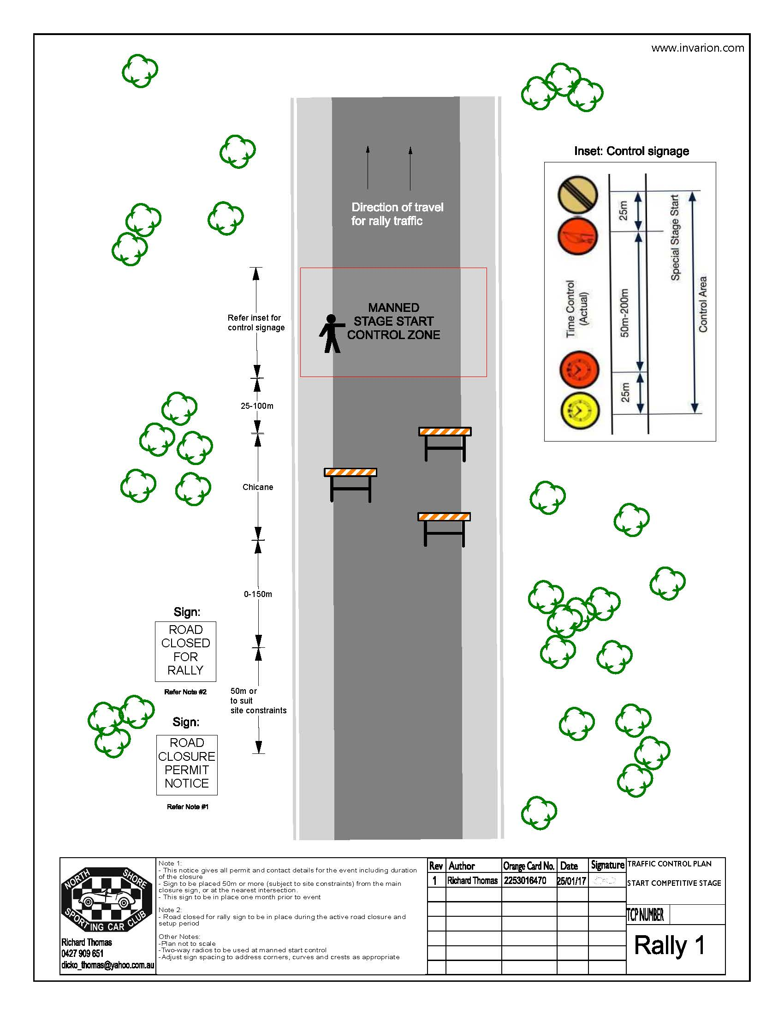
Club
Logo
- TCP – Intermediate – Manned
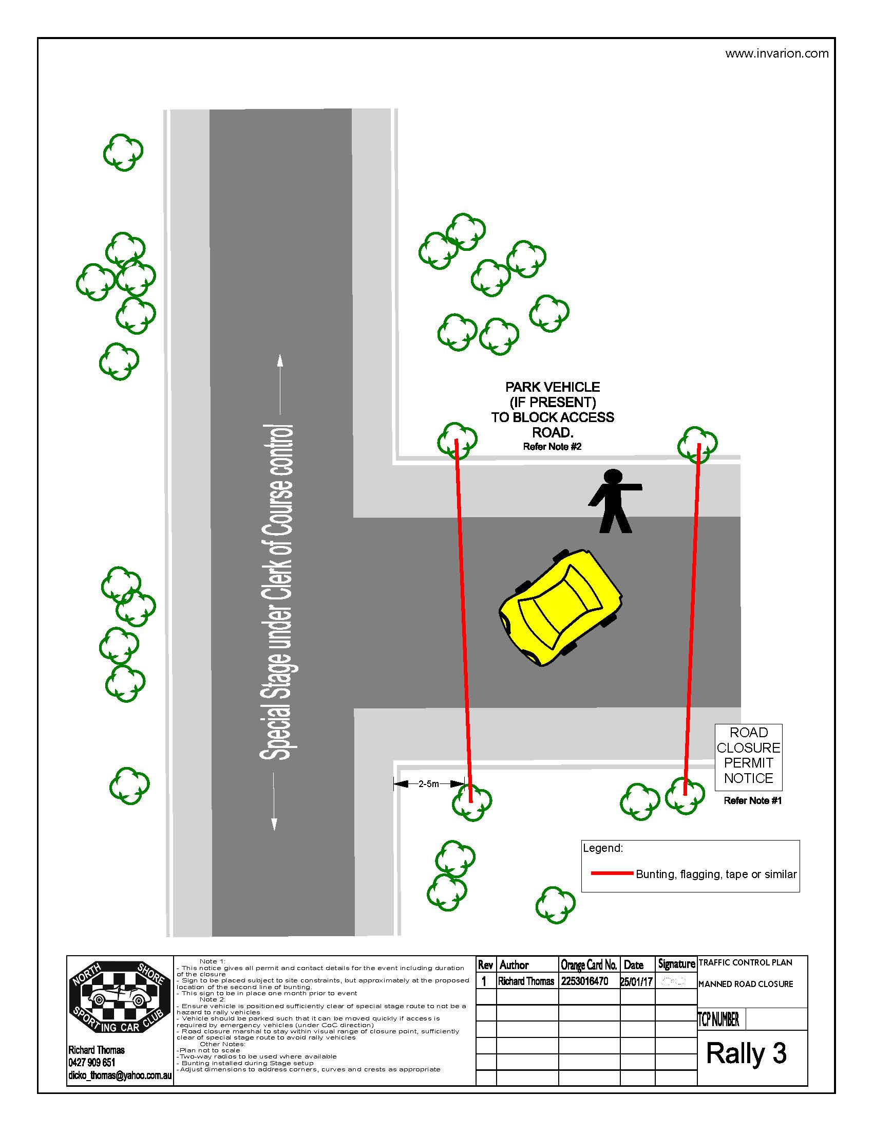
Club
Logo
- TCP - Intermediate Unmanned 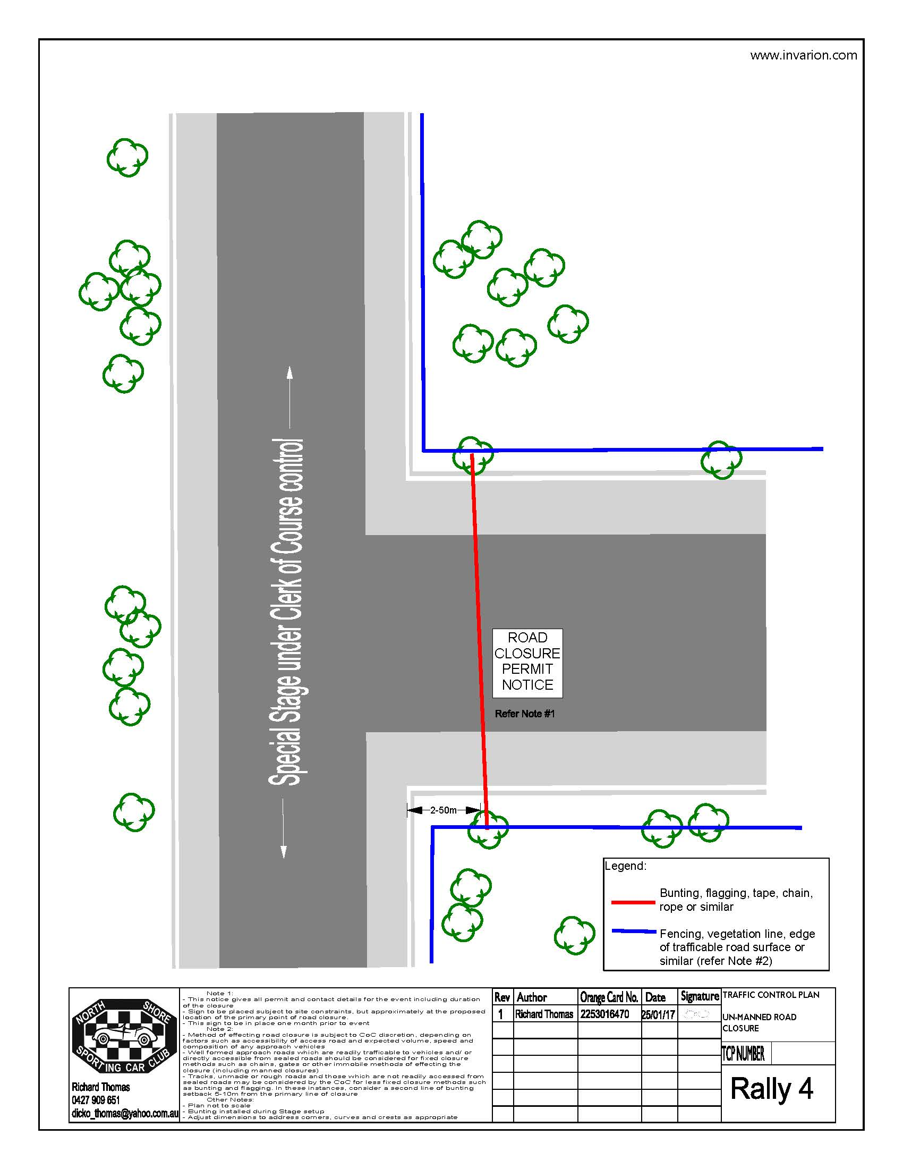
Club
Logo
- TCP – Stage Finish
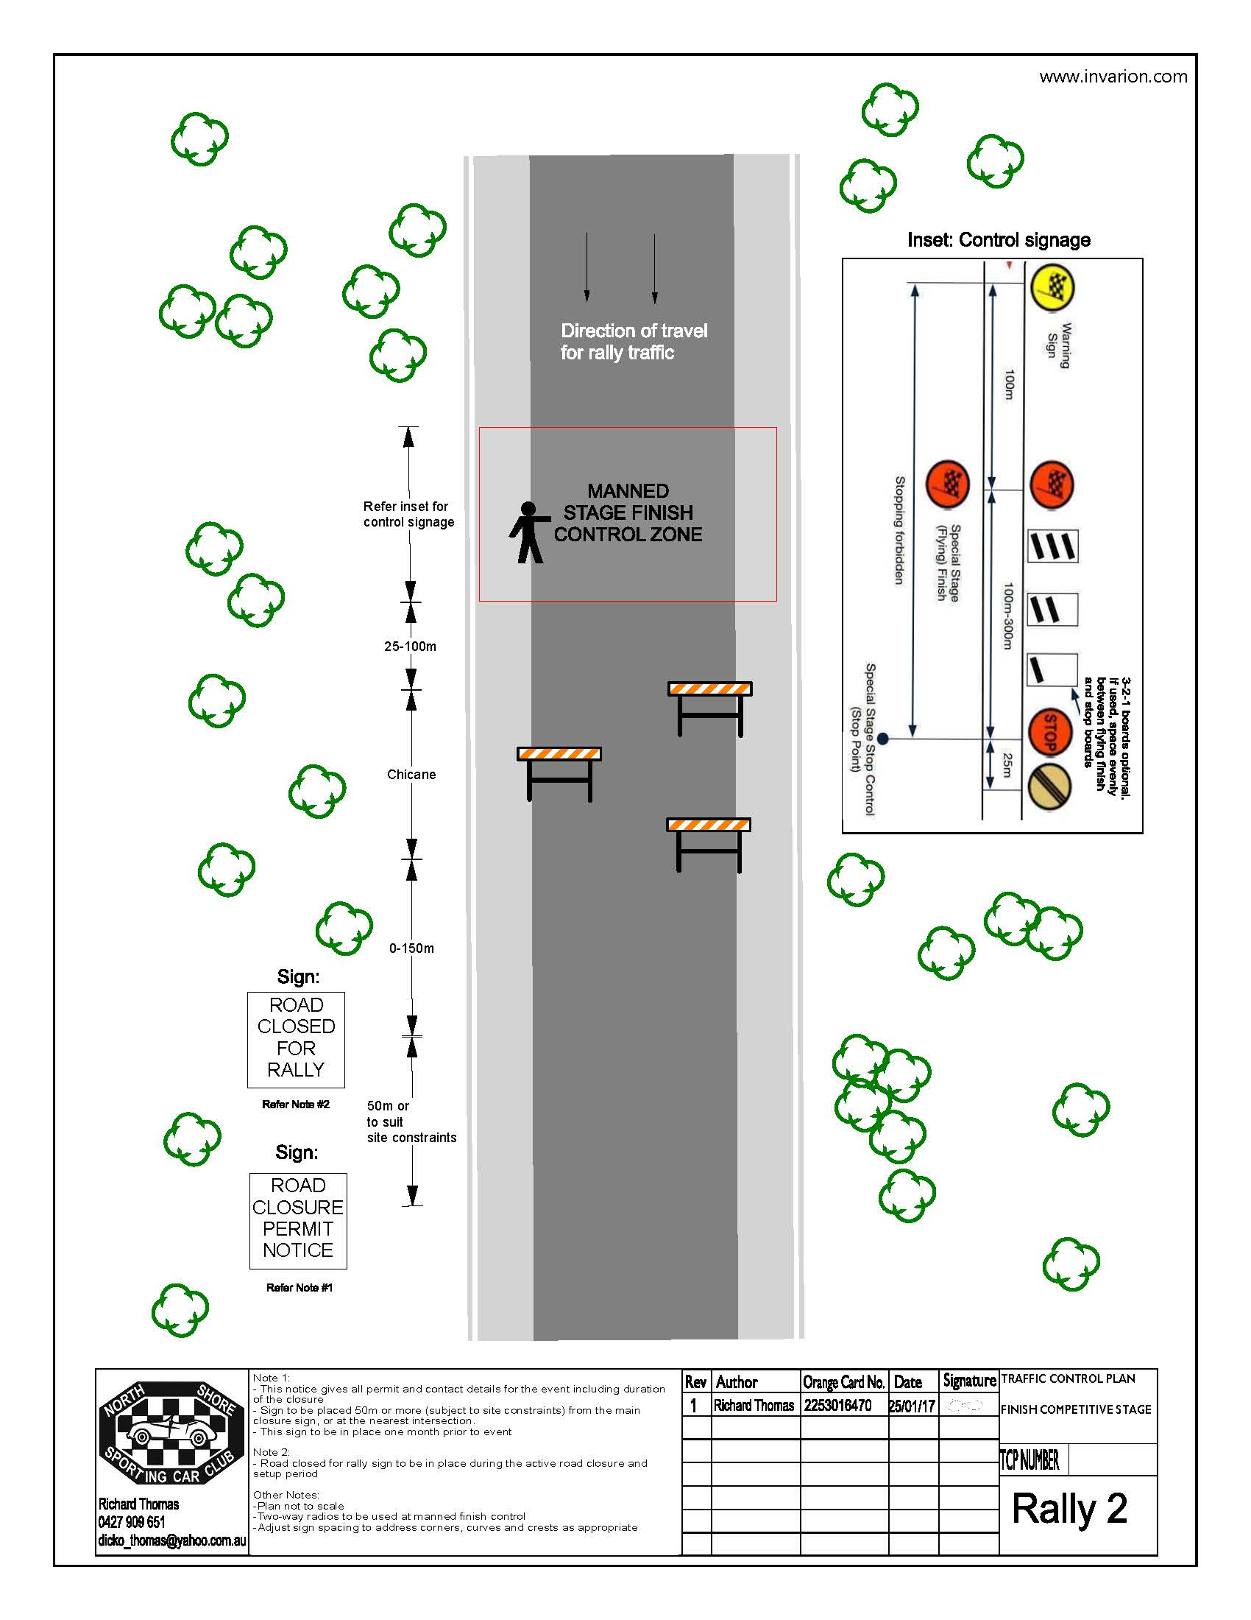
Club
Logo
- TCP – Spectator Point
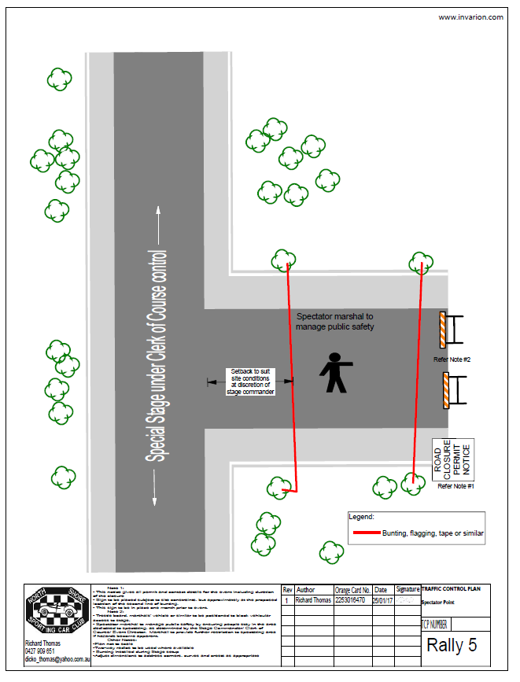
Club
Logo
- Road Closure Locations [example]

Day | Stage | Intersection | Manned | Comment | Manned Road Closures | Spectator Points
[date] | SS1/5  Hampton | Unnamed Rd | Yes | Stage Start | 5 | 1
 |  | Unnamed road/Tea Tree Ridge Rd | Yes | Spectator Point 1/5
 |  | Tea Tree Ridge Rd/Bindo Boundary Rd | Yes | MRC 1
 |  | Bindo Boundary Rd/Airstrip Rd | Yes | MRC 2
 |  | Evans Rd/Duckmaloi Rd | Yes | Stage Finish
 | SS2/6  Jenolan | Unnamed road | Yes | Stage Start | 4 | 1
 |  | Mini Mini Range Rd/Rudys Rd | Yes | Spectator Point 2/6
 |  | Rudys Rd/Lipeys Creek Rd | Yes | MRC 3
 |  | Unnamed road/Black Range Rd | Yes | Stage Finish

